EXPERIMENT – 4:
VERIFICATION OF SYSTEM PROPERTIES: LINEARITY, TIME INVARIANCE, CAUSALITY AND STABILITY

OBJECTIVE :
To verify the linearity and time-invariance properties of continuous-time and discrete-time systems using suitable input signals and system responses.

MATLAB CODING :
% Experiment 11: Linearity and Time Invariance
clc; clear; close all;
t = -1:0.001:1;
x1 = sin(2*pi*5*t); x2 = cos(2*pi*5*t);
a = 2; b = 3; t0 = 0.2;
T = @(x) 2*x;
lhs = T(a*x1+b*x2);
rhs = a*T(x1)+b*T(x2);
linError = max(abs(lhs-rhs));
xDelay = sin(2*pi*5*(t-t0));
lhsTI = T(xDelay);
rhsTI = T(x1);
rhsTIshift = interp1(t,rhsTI,t-t0,'linear',0);
tiError = max(abs(lhsTI-rhsTIshift));
figure;
subplot(2,1,1); plot(t,lhs-rhs); grid on; title('Linearity Error');
subplot(2,1,2); plot(t,lhsTI-rhsTIshift); grid on; title('Time-Invariance Error');
fprintf('Linearity error = %g\n',linError);
fprintf('Time-invariance error = %g\n',tiError);

OUTPUT :
To verify the linearity and time-invariance properties of continuous-time and discrete-time systems using suitable input signals and system responses.
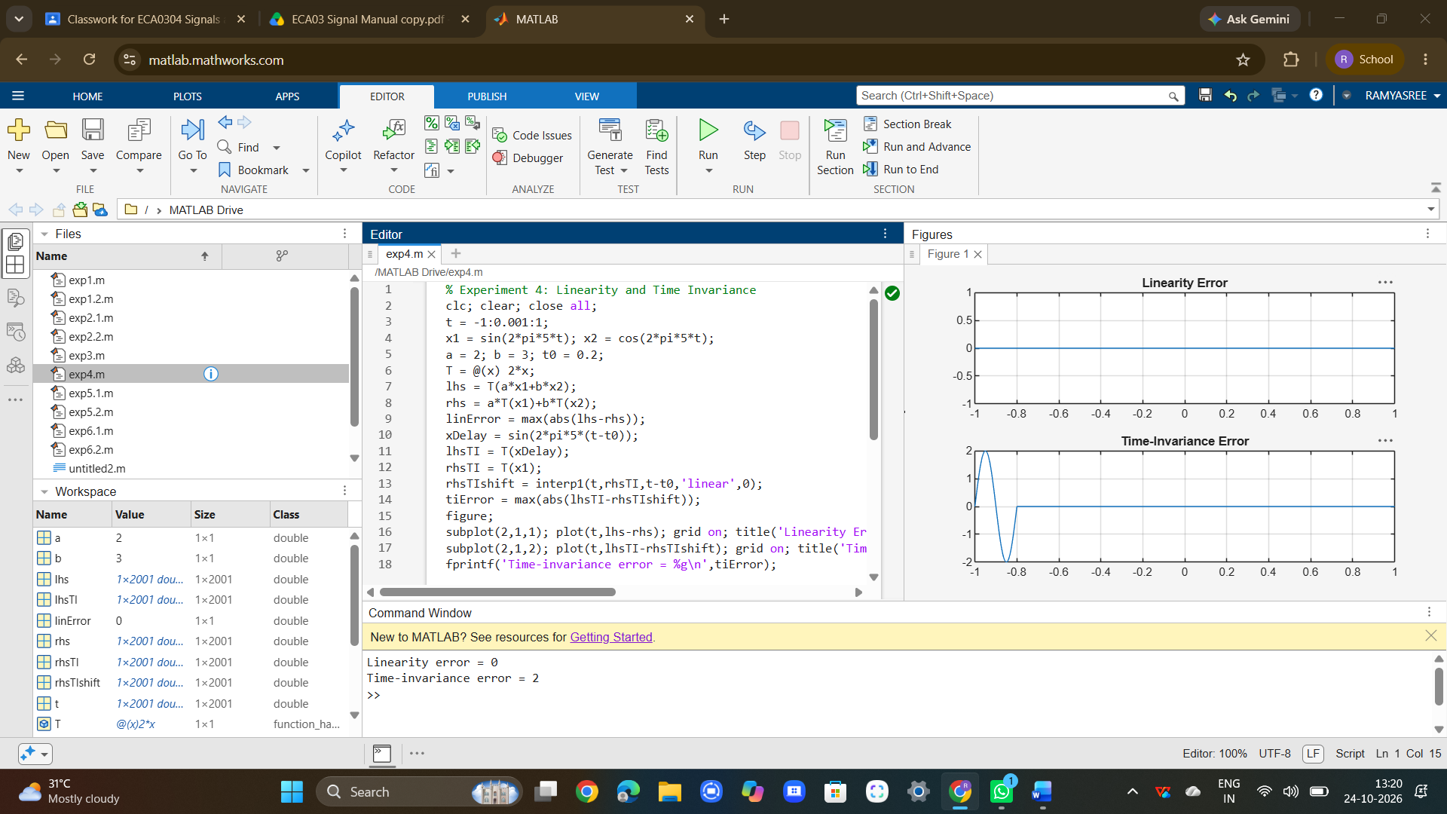

RESULT :
The system properties were successfully verified and classified. Linearity, time invariance, causality, memory, and stability were analyzed. The results confirmed the system behavior for practical applications.

